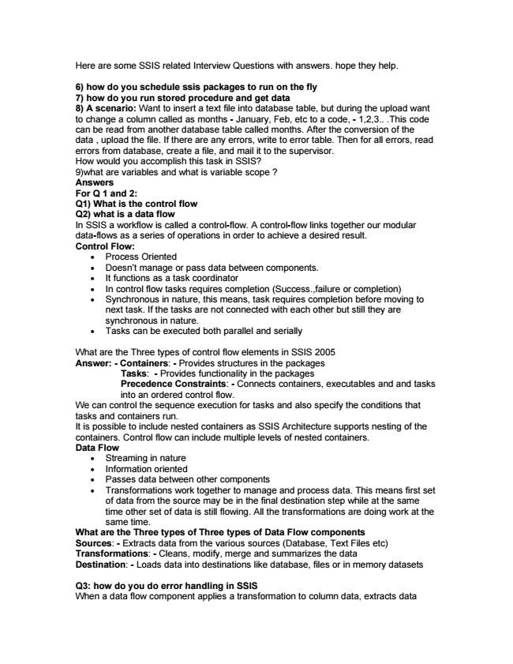

Here are some SSIS related Interview Questions with answers. hope they help.

6) how do you schedule ssis packages to run on the fly 7) how do you run stored procedure and get data 8) A scenario: Want to insert a text file into database table, but during the upload want to change a column called as months - January, Feb, etc to a code, - 1,2,3.. .This code can be read from another database table called months. After the conversion of the data , upload the file. If there are any errors, write to error table. Then for all errors, read errors from database, create a file, and mail it to the supervisor. How would you accomplish this task in SSIS? 9)what are variables and what is variable scope ? Answers For Q 1 and 2: Q1) What is the control flow Q2) what is a data flow In SSIS a workflow is called a control-flow. A control-flow links together our modular data-flows as a series of operations in order to achieve a desired result. Control Flow:

• Process Oriented

• Doesn’t manage or pass data between components.

• It functions as a task coordinator

• In control flow tasks requires completion (Success.,failure or completion)

• Synchronous in nature, this means, task requires completion before moving to next task. If the tasks are not connected with each other but still they are synchronous in nature.

• Tasks can be executed both parallel and serially

What are the Three types of control flow elements in SSIS 2005 Answer: - Containers: - Provides structures in the packages

Tasks: - Provides functionality in the packages Precedence Constraints: - Connects containers, executables and and tasks into an ordered control flow. We can control the sequence execution for tasks and also specify the conditions that tasks and containers run. It is possible to include nested containers as SSIS Architecture supports nesting of the containers. Control flow can include multiple levels of nested containers. Data Flow

• Streaming in nature

• Information oriented

• Passes data between other components

• Transformations work together to manage and process data. This means first set of data from the source may be in the final destination step while at the same time other set of data is still flowing. All the transformations are doing work at the same time. What are the Three types of Three types of Data Flow components Sources: - Extracts data from the various sources (Database, Text Files etc) Transformations: - Cleans, modify, merge and summarizes the data Destination: - Loads data into destinations like database, files or in memory datasets

Q3: how do you do error handling in SSIS When a data flow component applies a transformation to column data, extracts data

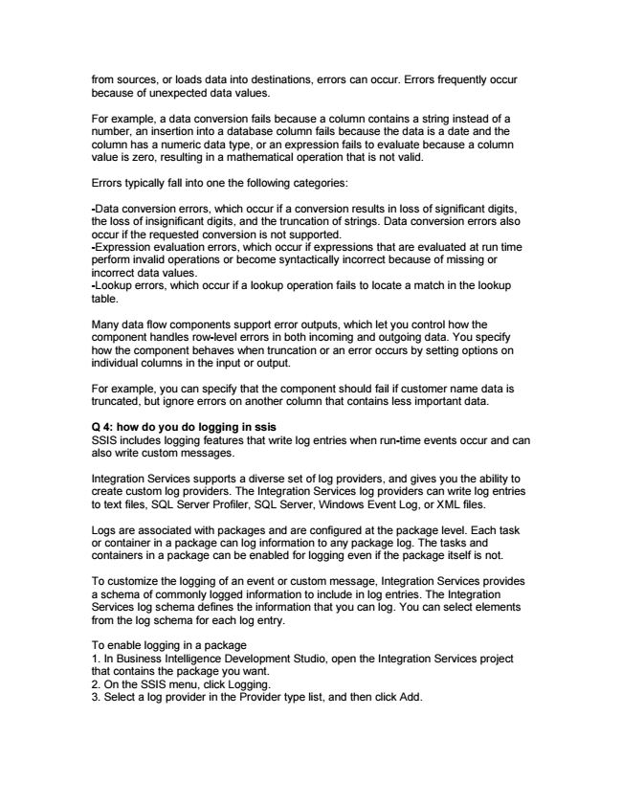

from sources, or loads data into destinations, errors can occur. Errors frequently occur because of unexpected data values.

For example, a data conversion fails because a column contains a string instead of a number, an insertion into a database column fails because the data is a date and the column has a numeric data type, or an expression fails to evaluate because a column value is zero, resulting in a mathematical operation that is not valid.

Errors typically fall into one the following categories:

-Data conversion errors, which occur if a conversion results in loss of significant digits, the loss of insignificant digits, and the truncation of strings. Data conversion errors also occur if the requested conversion is not supported. -Expression evaluation errors, which occur if expressions that are evaluated at run time perform invalid operations or become syntactically incorrect because of missing or incorrect data values. -Lookup errors, which occur if a lookup operation fails to locate a match in the lookup table.

Many data flow components support error outputs, which let you control how the component handles row-level errors in both incoming and outgoing data. You specify how the component behaves when truncation or an error occurs by setting options on individual columns in the input or output.

For example, you can specify that the component should fail if customer name data is truncated, but ignore errors on another column that contains less important data.

Q 4: how do you do logging in ssis SSIS includes logging features that write log entries when run-time events occur and can also write custom messages.

Integration Services supports a diverse set of log providers, and gives you the ability to create custom log providers. The Integration Services log providers can write log entries to text files, SQL Server Profiler, SQL Server, Windows Event Log, or XML files.

Logs are associated with packages and are configured at the package level. Each task or container in a package can log information to any package log. The tasks and containers in a package can be enabled for logging even if the package itself is not.

To customize the logging of an event or custom message, Integration Services provides a schema of commonly logged information to include in log entries. The Integration Services log schema defines the information that you can log. You can select elements from the log schema for each log entry.

To enable logging in a package 1. In Business Intelligence Development Studio, open the Integration Services project that contains the package you want. 2. On the SSIS menu, click Logging. 3. Select a log provider in the Provider type list, and then click Add.

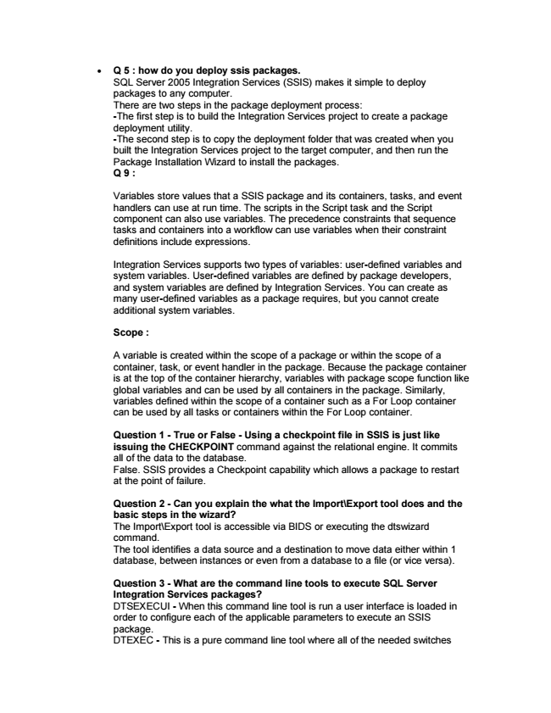

• Q 5 : how do you deploy ssis packages. SQL Server 2005 Integration Services (SSIS) makes it simple to deploy packages to any computer. There are two steps in the package deployment process: -The first step is to build the Integration Services project to create a package deployment utility. -The second step is to copy the deployment folder that was created when you built the Integration Services project to the target computer, and then run the Package Installation Wizard to install the packages. Q 9 :

Variables store values that a SSIS package and its containers, tasks, and event handlers can use at run time. The scripts in the Script task and the Script component can also use variables. The precedence constraints that sequence tasks and containers into a workflow can use variables when their constraint definitions include expressions.

Integration Services supports two types of variables: user-defined variables and system variables. User-defined variables are defined by package developers, and system variables are defined by Integration Services. You can create as many user-defined variables as a package requires, but you cannot create additional system variables.

**Scope :**

A variable is created within the scope of a package or within the scope of a container, task, or event handler in the package. Because the package container is at the top of the container hierarchy, variables with package scope function like global variables and can be used by all containers in the package. Similarly, variables defined within the scope of a container such as a For Loop container can be used by all tasks or containers within the For Loop container.

Question 1 - True or False - Using a checkpoint file in SSIS is just like issuing the CHECKPOINT command against the relational engine. It commits all of the data to the database. False. SSIS provides a Checkpoint capability which allows a package to restart at the point of failure.

Question 2 - Can you explain the what the Import\Export tool does and the basic steps in the wizard? The Import\Export tool is accessible via BIDS or executing the dtswizard command. The tool identifies a data source and a destination to move data either within 1 database, between instances or even from a database to a file (or vice versa).

Question 3 - What are the command line tools to execute SQL Server Integration Services packages? DTSEXECUI - When this command line tool is run a user interface is loaded in order to configure each of the applicable parameters to execute an SSIS package. DTEXEC - This is a pure command line tool where all of the needed switches

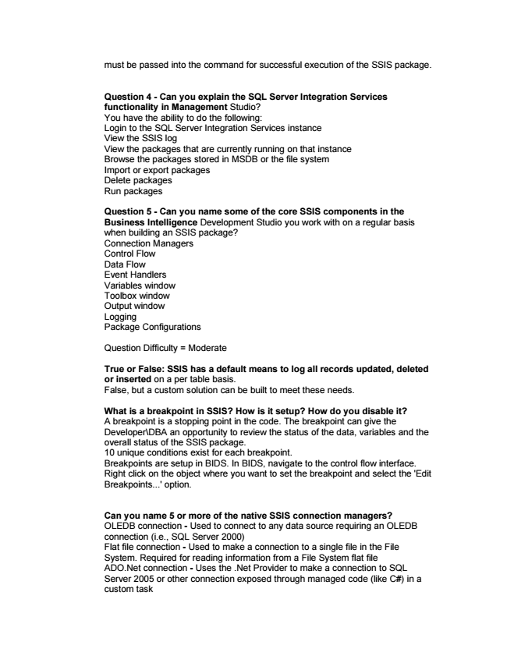

must be passed into the command for successful execution of the SSIS package.

Question 4 - Can you explain the SQL Server Integration Services functionality in Management Studio? You have the ability to do the following: Login to the SQL Server Integration Services instance View the SSIS log View the packages that are currently running on that instance Browse the packages stored in MSDB or the file system Import or export packages Delete packages Run packages

Question 5 - Can you name some of the core SSIS components in the Business Intelligence Development Studio you work with on a regular basis when building an SSIS package? Connection Managers Control Flow Data Flow Event Handlers Variables window Toolbox window Output window Logging Package Configurations

Question Difficulty = Moderate

**True or False: SSIS has a default means to log all records updated, deleted or inserted on a per table basis. False, but a custom solution can be built to meet these needs.**

What is a breakpoint in SSIS? How is it setup? How do you disable it? A breakpoint is a stopping point in the code. The breakpoint can give the Developer\DBA an opportunity to review the status of the data, variables and the overall status of the SSIS package. 10 unique conditions exist for each breakpoint. Breakpoints are setup in BIDS. In BIDS, navigate to the control flow interface. Right click on the object where you want to set the breakpoint and select the 'Edit Breakpoints...' option.

Can you name 5 or more of the native SSIS connection managers? OLEDB connection - Used to connect to any data source requiring an OLEDB connection (i.e., SQL Server 2000) Flat file connection - Used to make a connection to a single file in the File System. Required for reading information from a File System flat file ADO.Net connection - Uses the .Net Provider to make a connection to SQL Server 2005 or other connection exposed through managed code (like C#) in a custom task

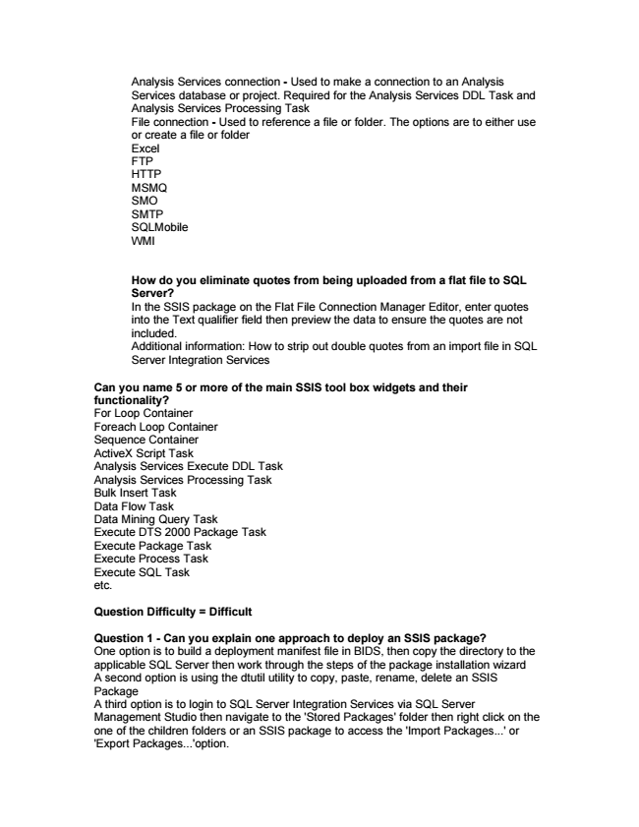

Analysis Services connection - Used to make a connection to an Analysis Services database or project. Required for the Analysis Services DDL Task and Analysis Services Processing Task File connection - Used to reference a file or folder. The options are to either use or create a file or folder Excel FTP HTTP MSMQ SMO SMTP SQLMobile WMI

How do you eliminate quotes from being uploaded from a flat file to SQL Server? In the SSIS package on the Flat File Connection Manager Editor, enter quotes into the Text qualifier field then preview the data to ensure the quotes are not included. Additional information: How to strip out double quotes from an import file in SQL Server Integration Services

Can you name 5 or more of the main SSIS tool box widgets and their functionality? For Loop Container Foreach Loop Container Sequence Container ActiveX Script Task Analysis Services Execute DDL Task Analysis Services Processing Task Bulk Insert Task Data Flow Task Data Mining Query Task Execute DTS 2000 Package Task Execute Package Task Execute Process Task Execute SQL Task etc.

**Question Difficulty = Difficult**

Question 1 - Can you explain one approach to deploy an SSIS package? One option is to build a deployment manifest file in BIDS, then copy the directory to the applicable SQL Server then work through the steps of the package installation wizard A second option is using the dtutil utility to copy, paste, rename, delete an SSIS Package A third option is to login to SQL Server Integration Services via SQL Server Management Studio then navigate to the 'Stored Packages' folder then right click on the one of the children folders or an SSIS package to access the 'Import Packages...' or 'Export Packages...'option.

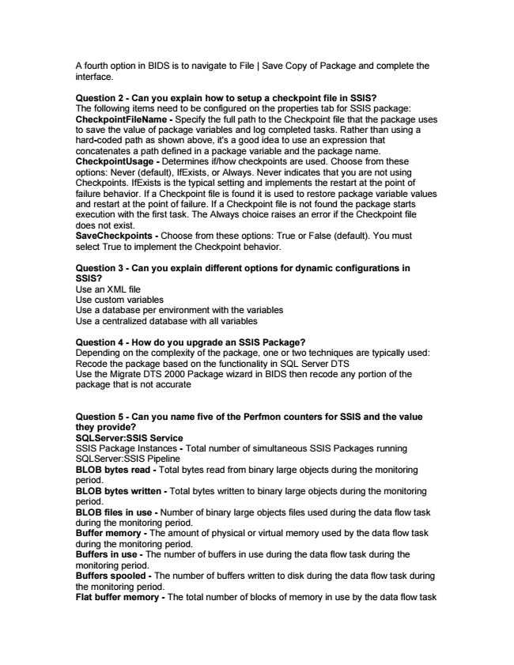

A fourth option in BIDS is to navigate to File | Save Copy of Package and complete the interface.

Question 2 - Can you explain how to setup a checkpoint file in SSIS? The following items need to be configured on the properties tab for SSIS package: CheckpointFileName - Specify the full path to the Checkpoint file that the package uses to save the value of package variables and log completed tasks. Rather than using a hard-coded path as shown above, it's a good idea to use an expression that concatenates a path defined in a package variable and the package name. CheckpointUsage - Determines if/how checkpoints are used. Choose from these options: Never (default), IfExists, or Always. Never indicates that you are not using Checkpoints. IfExists is the typical setting and implements the restart at the point of failure behavior. If a Checkpoint file is found it is used to restore package variable values and restart at the point of failure. If a Checkpoint file is not found the package starts execution with the first task. The Always choice raises an error if the Checkpoint file does not exist. SaveCheckpoints - Choose from these options: True or False (default). You must select True to implement the Checkpoint behavior.

Question 3 - Can you explain different options for dynamic configurations in SSIS? Use an XML file Use custom variables Use a database per environment with the variables Use a centralized database with all variables

Question 4 - How do you upgrade an SSIS Package? Depending on the complexity of the package, one or two techniques are typically used: Recode the package based on the functionality in SQL Server DTS Use the Migrate DTS 2000 Package wizard in BIDS then recode any portion of the package that is not accurate

Question 5 - Can you name five of the Perfmon counters for SSIS and the value they provide? SQLServer:SSIS Service SSIS Package Instances - Total number of simultaneous SSIS Packages running SQLServer:SSIS Pipeline BLOB bytes read - Total bytes read from binary large objects during the monitoring period. BLOB bytes written - Total bytes written to binary large objects during the monitoring period. BLOB files in use - Number of binary large objects files used during the data flow task during the monitoring period. Buffer memory - The amount of physical or virtual memory used by the data flow task during the monitoring period. Buffers in use - The number of buffers in use during the data flow task during the monitoring period. Buffers spooled - The number of buffers written to disk during the data flow task during the monitoring period. Flat buffer memory - The total number of blocks of memory in use by the data flow task

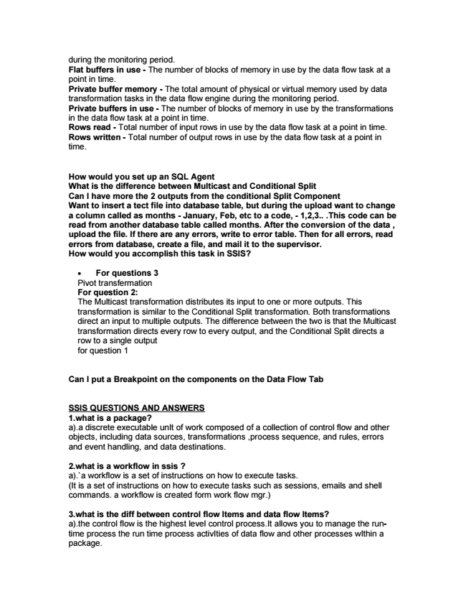

during the monitoring period. Flat buffers in use - The number of blocks of memory in use by the data flow task at a point in time. Private buffer memory - The total amount of physical or virtual memory used by data transformation tasks in the data flow engine during the monitoring period. Private buffers in use - The number of blocks of memory in use by the transformations in the data flow task at a point in time. Rows read - Total number of input rows in use by the data flow task at a point in time. Rows written - Total number of output rows in use by the data flow task at a point in time.

**How would you set up an SQL Agent What is the difference between Multicast and Conditional Split Can I have more the 2 outputs from the conditional Split Component Want to insert a tect file into database table, but during the upload want to change a column called as months - January, Feb, etc to a code, - 1,2,3.. .This code can be read from another database table called months. After the conversion of the data , upload the file. If there are any errors, write to error table. Then for all errors, read errors from database, create a file, and mail it to the supervisor. How would you accomplish this task in SSIS?**

• For questions 3 Pivot transfermation For question 2: The Multicast transformation distributes its input to one or more outputs. This transformation is similar to the Conditional Split transformation. Both transformations direct an input to multiple outputs. The difference between the two is that the Multicast transformation directs every row to every output, and the Conditional Split directs a row to a single output for question 1

**Can I put a Breakpoint on the components on the Data Flow Tab**

SSIS QUESTIONS AND ANSWERS 1.what is a package? a).a discrete executable unIt of work composed of a collection of control flow and other objects, including data sources, transformations ,process sequence, and rules, errors and event handling, and data destinations.

2.what is a workflow in ssis ? a).`a workflow is a set of instructions on how to execute tasks. (It is a set of instructions on how to execute tasks such as sessions, emails and shell commands. a workflow is created form work flow mgr.)

3.what is the diff between control flow Items and data flow Items? a).the control flow is the highest level control process.It allows you to manage the run- time process the run time process activIties of data flow and other processes wIthin a package.

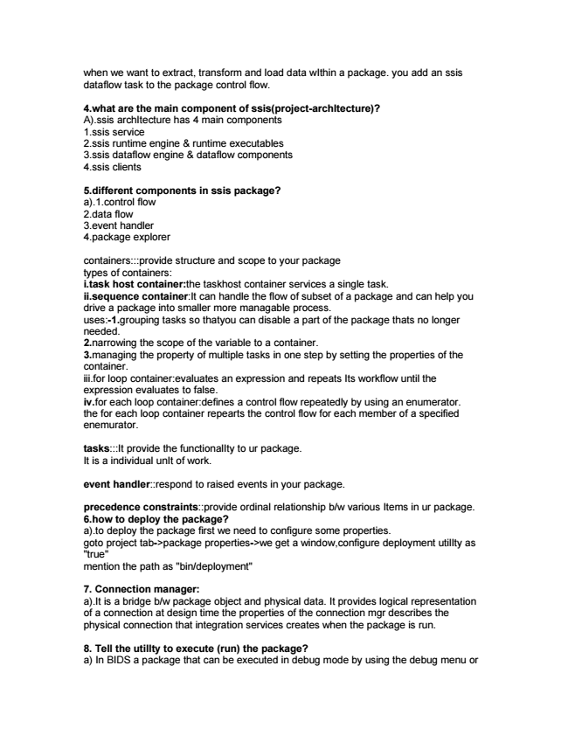

when we want to extract, transform and load data wIthin a package. you add an ssis dataflow task to the package control flow.

4.what are the main component of ssis(project-archItecture)? A).ssis archItecture has 4 main components 1.ssis service 2.ssis runtime engine & runtime executables 3.ssis dataflow engine & dataflow components 4.ssis clients

5.different components in ssis package? a).1.control flow 2.data flow 3.event handler 4.package explorer

containers:::provide structure and scope to your package types of containers: i.task host container:the taskhost container services a single task. ii.sequence container:It can handle the flow of subset of a package and can help you drive a package into smaller more managable process. uses:-1.grouping tasks so thatyou can disable a part of the package thats no longer needed. 2.narrowing the scope of the variable to a container. 3.managing the property of multiple tasks in one step by setting the properties of the container. iii.for loop container:evaluates an expression and repeats Its workflow until the expression evaluates to false. iv.for each loop container:defines a control flow repeatedly by using an enumerator. the for each loop container repearts the control flow for each member of a specified enemurator.

tasks:::It provide the functionalIty to ur package. It is a individual unIt of work.

event handler::respond to raised events in your package.

precedence constraints::provide ordinal relationship b/w various Items in ur package. 6.how to deploy the package? a).to deploy the package first we need to configure some properties. goto project tab->package properties->we get a window,configure deployment utilIty as "true" mention the path as "bin/deployment"

7. Connection manager: a).It is a bridge b/w package object and physical data. It provides logical representation of a connection at design time the properties of the connection mgr describes the physical connection that integration services creates when the package is run.

8. Tell the utilIty to execute (run) the package? a) In BIDS a package that can be executed in debug mode by using the debug menu or

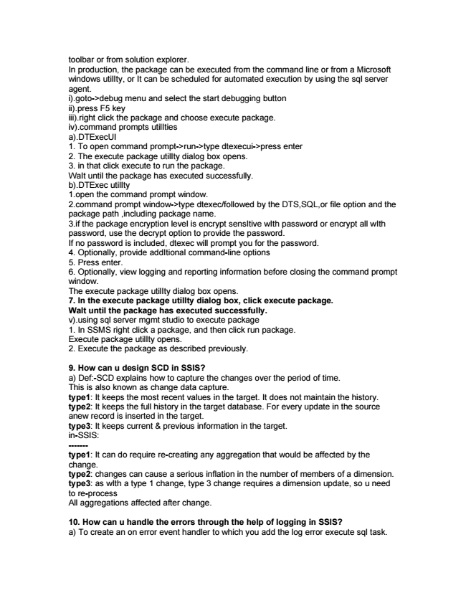

toolbar or from solution explorer. In production, the package can be executed from the command line or from a Microsoft windows utilIty, or It can be scheduled for automated execution by using the sql server agent. i).goto->debug menu and select the start debugging button ii).press F5 key iii).right click the package and choose execute package. iv).command prompts utilIties a).DTExecUI 1. To open command prompt->run->type dtexecui->press enter 2. The execute package utilIty dialog box opens. 3. in that click execute to run the package. WaIt until the package has executed successfully. b).DTExec utilIty 1.open the command prompt window. 2.command prompt window->type dtexec/followed by the DTS,SQL,or file option and the package path ,including package name. 3.if the package encryption level is encrypt sensItive wIth password or encrypt all wIth password, use the decrypt option to provide the password. If no password is included, dtexec will prompt you for the password. 4. Optionally, provide addItional command-line options 5. Press enter. 6. Optionally, view logging and reporting information before closing the command prompt window. The execute package utilIty dialog box opens. 7. In the execute package utilIty dialog box, click execute package. WaIt until the package has executed successfully. v).using sql server mgmt studio to execute package 1. In SSMS right click a package, and then click run package. Execute package utilIty opens. 2. Execute the package as described previously.

9. How can u design SCD in SSIS? a) Def:-SCD explains how to capture the changes over the period of time. This is also known as change data capture. type1: It keeps the most recent values in the target. It does not maintain the history. type2: It keeps the full history in the target database. For every update in the source anew record is inserted in the target. type3: It keeps current & previous information in the target. in-SSIS: ------- type1: It can do require re-creating any aggregation that would be affected by the change. type2: changes can cause a serious inflation in the number of members of a dimension. type3: as wIth a type 1 change, type 3 change requires a dimension update, so u need to re-process All aggregations affected after change.

10. How can u handle the errors through the help of logging in SSIS? a) To create an on error event handler to which you add the log error execute sql task.

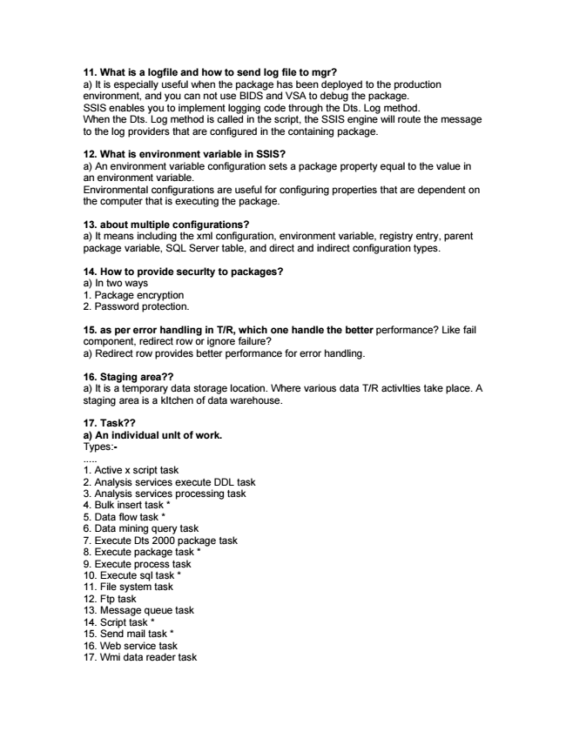

11. What is a logfile and how to send log file to mgr? a) It is especially useful when the package has been deployed to the production environment, and you can not use BIDS and VSA to debug the package. SSIS enables you to implement logging code through the Dts. Log method. When the Dts. Log method is called in the script, the SSIS engine will route the message to the log providers that are configured in the containing package.

12. What is environment variable in SSIS? a) An environment variable configuration sets a package property equal to the value in an environment variable. Environmental configurations are useful for configuring properties that are dependent on the computer that is executing the package.

13. about multiple configurations? a) It means including the xml configuration, environment variable, registry entry, parent package variable, SQL Server table, and direct and indirect configuration types.

14. How to provide securIty to packages? a) In two ways 1. Package encryption 2. Password protection.

15. as per error handling in T/R, which one handle the better performance? Like fail component, redirect row or ignore failure? a) Redirect row provides better performance for error handling.

16. Staging area?? a) It is a temporary data storage location. Where various data T/R activIties take place. A staging area is a kItchen of data warehouse.

17. Task?? a) An individual unIt of work. Types:- ..... 1. Active x script task 2. Analysis services execute DDL task 3. Analysis services processing task 4. Bulk insert task * 5. Data flow task * 6. Data mining query task 7. Execute Dts 2000 package task 8. Execute package task * 9. Execute process task 10. Execute sql task * 11. File system task 12. Ftp task 13. Message queue task 14. Script task * 15. Send mail task * 16. Web service task 17. Wmi data reader task